Area and Perimeter Review NAME _________________
SHOW ALL YOUR WORK
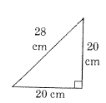  1. A=____________ | 2. Distance around =____________  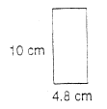
3. Distance inside:___________  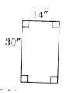 | 4. A= ________________  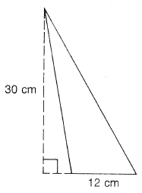
5. A = ____________P=________________  A square with sides equal to 12 in. | 6. P = __________  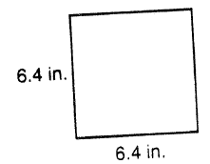
7. A = ______________  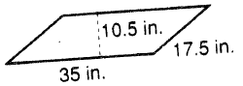 | 8. A= ________________ P=_____________  A rectangular flower bed that is 3.5 feet wide and 4.5 feet long.
9. A= __________________  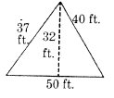 | 10. Distance around = ______________  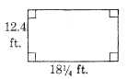
11. Distance inside:________________  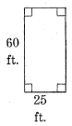 | 12. A = ______________________  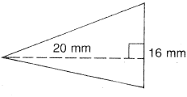
13. P= ____________ A= _____________  A square with sides equal to 10.5 inches. | 14. P = ____________________  A square with sides equal to 7.5 meters.
15. A = ______________________  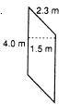 | 16. A = ____________ P = _____________  A rectangular flower bed that is 5.6 feet wide and 7.5 feet long

