Area and Perimeter Review #2 NAME _________________
SHOW ALL YOUR WORK
1. Base:________ A=____________  The height of a parallelogram is 4.5 cm.  The base is twice the height. What is  base. Find the area. the area? | 2. Distance around =____________  How many feet of border are needed  to go around a square bulletin board  that is 4.5 ft on each side?
3. Distance inside:___________  What is the area of the shaded region?  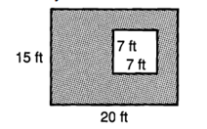 | . A= ________________  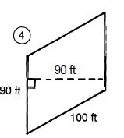
5. A = ____________P=________________  A square with sides equal to 7 in. | 6. P = __________  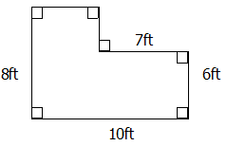
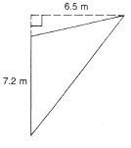  7. A = ______________ | 8. A= ________________ P=_____________  A rectangular flower bed that is 5.5 feet wide and 7 feet long.

