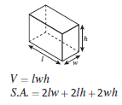
Name:___________________ SOL: 6.10d Surface Area/Volume Practice Formula:

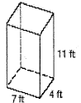  - 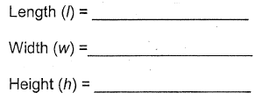 | Volume:  __________________ | Surface Area:  __________________
- 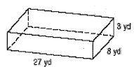 | Volume:  __________________ | Surface Area:  __________________
- 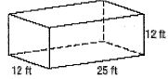 | Volume:  __________________ | Surface Area:  __________________
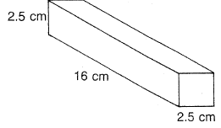 | Volume:  __________________ | Surface Area:  __________________
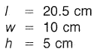 | Volume:  __________________ | Surface Area:  __________________
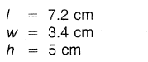 | Volume:  __________________ | Surface Area:  __________________
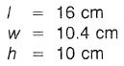 | Volume:  __________________ | Surface Area:  __________________
- 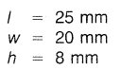 | Volume:  __________________ | Surface Area:  __________________

