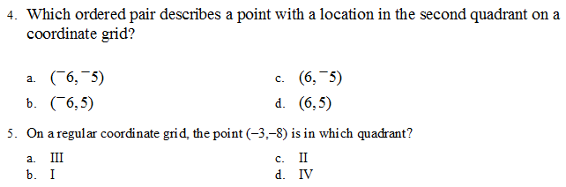
COORDINATE REVIEW
Level 1- Answer all questions
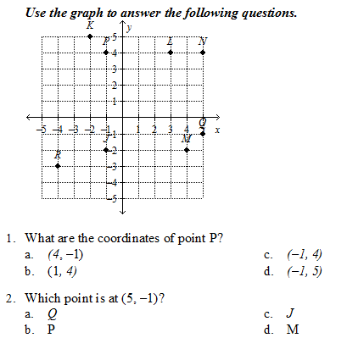

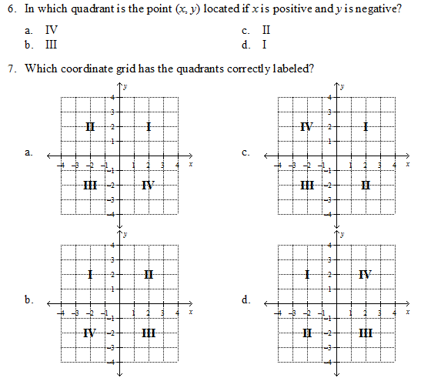

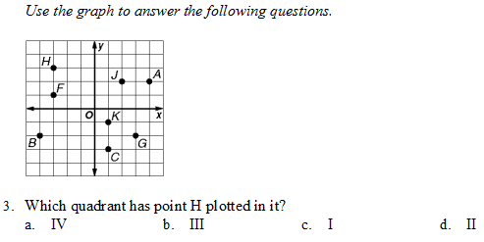

Level 2- Answer 5 questions correctly. Be careful, the questions are not in order.
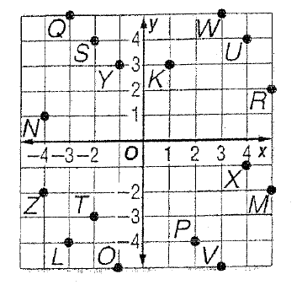
Use the coordinate plane at the right to identify the point for each ordered pair.
8) (-2, 4) ______
9) (-2, -3) ______
10) (4, 4) ______
11) (3, -5) ______
12) (4, -1) ______
13) (-1,3) ______
14) (-4. -2) ______

Now that you are finished, answer the following questions. When you are finished have your teacher check.
- ______ The horizontal axis on the coordinate plane A) Origin

- ______ The center of the coordinate plane B) Decartes
- ______ The vertical axis on the coordinate plane C) Y Axis
- ______ The exact location of a point on the coordinate plane D) X Axis
- ______ The mathematician who created the coordinate plane E) Ordered Pair

