***Note for SOL 6.15 – Measures of Center***

***(Mean, Median, and Mode) and Range***

**6.15 The student will**

**a) describe mean as balance point; and**

**b) decide which measure of center is appropriate for a given purpose.**

* Measures of center include: , , .
* **Mean, median, and mode** are measures of center that are useful for describing the average for different situations.
* **Mean** works well for sets of data with no very high or low numbers.
* **Median** is a good choice when data sets have a couple of values much higher or lower than most of the others.
* **Mode** is a good descriptor to use when the set of data has some identical values or when data are not conducive to computation of other measures of central tendency, as when working with data in a yes or no survey.
* The _________ is the _________ of the data set.
* **Average** is found by adding the numbers in the data set together and dividing by the number of data pieces in the set.
* _________ can be defined as the point on a number line where the data distribution is _________.
* This means that the **sum of the distances** from the mean of all the points above the mean is equal to the sum of the distances of all the data points below the mean.
* The _________ is the _________ value of a data set **in ranked order** (least to greatest or greatest to least).
* If there are an **odd** number of pieces of data, the median is the **middle value**.
* If there is an **even** number of pieces of data, the median is the **average of the two middle values**. (Hint: add the two middle numbers and divide by two)
* The _________ is the piece of data that occurs most _____________.
* If no value occurs more **often** than any other, there is no mode.
* If there is more than one value that occurs most often, all these most-frequently-occurring values are modes.
* When there are exactly two modes, the data set is bimodal.
* _________ is the **difference** between the number and the least number in a data set.

Mean, Median, & Mode:

Guided Example:

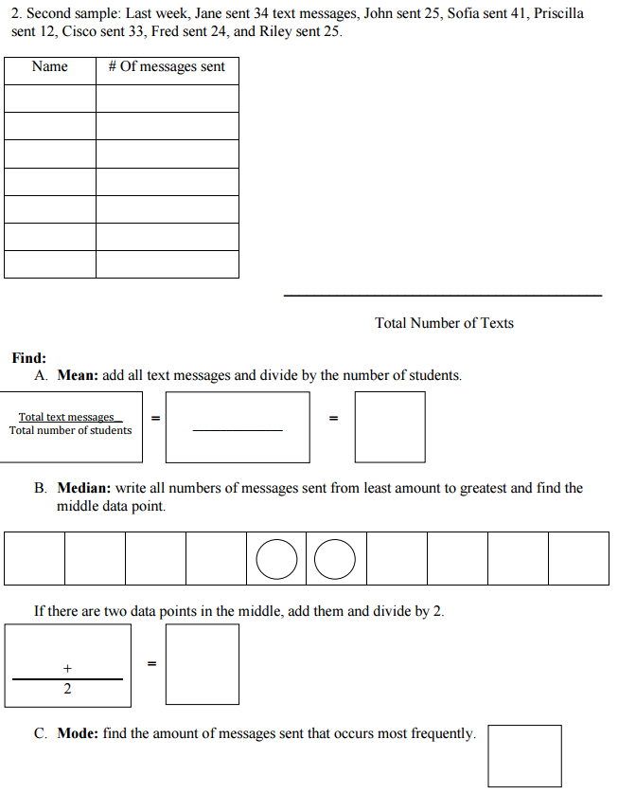



D. The Range of this data set would be: