Word Problems Name___________________________________

- Paul has been saving $8.50 each week for 16 weeks. How much money would he have left if he bought a game for $69.95 ?

- Maya has three diamonds that weigh 0.275 g each. Claire has two diamonds that weigh 0.412 g each. Who has more grams of diamonds?

- Keli had $45.63 in her bank account. She deposited a check from her aunt for $25. Then she wrote a check (withdrew) $14.93 to buy a necklace. Finally she deposited $28.50 in cash. How much money is in Keli’s account now?

- It is 106 miles to Washington, DC. There are 1.6 kilometers in each mile. How many kilometers is it to Washington, DC?

- Look at the table showing what Gwen bought. How much did Gwen spend?

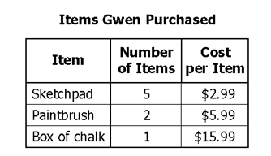

- Which store has the lowest price per CD?
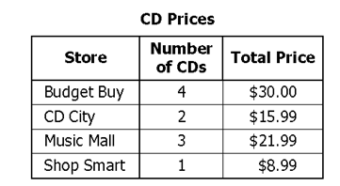

- A bonsai tree grows 0.056 cm per year. If the tree is currently 10 cm tall, how tall will it be 5 years from now?

- A phone call to the Phillipines costs $2.99 for the first minute and $0.89 for each additional minute. How much would a 5 minute phone call cost?

- How much would it cost to buy two loaves of bread and a gallon of milk?
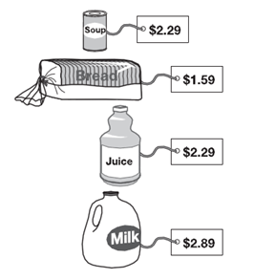

- If you bought all of these items and gave the cashier a ten dollar bill, how much change would you receive?

