**Virginia SOL 6.19 Pacing: 16 blocks**

The student will investigate and recognize

1. the identity properties for addition and multiplication;
2. the multiplicative property of zero; and
3. the inverse property for multiplication.

**Virginia SOL 6.18**

The student will solve one-step linear equations in one variable involving whole number coefficients and positive rational solutions.

**Virginia SOL 7.14**

The student will

1. solve one- and two- step linear equations in one variable; and
2. *solve practical problems requiring the solution of one-and two- step linear equations.*

*(NOT covered in Extended 6; covered in Extended 7)*

**Please see the Extended Grade 6 Curriculum Guide (pp. 69-73) for additional information.**

|  |  |  |
| --- | --- | --- |
| **Key Vocabulary for 6.19** | **Key Vocabulary SOL 6.18** | **Key Vocabulary SOL 7.14a** |
| additive identity property  associative property for addition  associative property for mult.  commutative property for add.  commutative property for mult.  distributive property  identity elements  inverses  multiplicative identity property  multiplicative inverse property  multiplicative property of zero  reciprocal | coefficient  equation  expression  numerical expression  term  variable  variable expression | inverse operations |



Expression

**a phrase…**

**no equal sign**

**3x + 4**

**OR**

**15 + 7**



**pairs of operations that “undo” each other**



0 + 7 = 7 so… 7 – 0 = 7

5 x 7 = 35 so… 35 ÷ 7 = 5

Inverse Operations

**the numerical factor**

**of a term**

Coefficient



2a + 6 + 4g³

The 2 and the 4 are coefficients!

Equation

**A mathematical statement…two expressions are equal.**

**=**

**2x + 1 = 5**

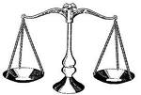

**5**

**2x+1**

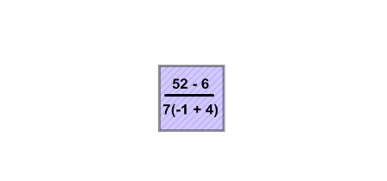

**expressions that only contain numbers**

42-3•2



Numerical Expression

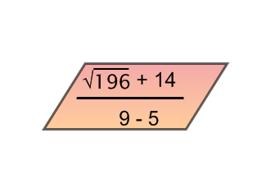

Reciprocal

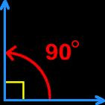

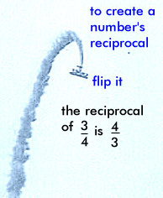

also called Multiplicative Inverse



Can be a …

Variable



**letter or other symbol that represents a number**

*x n b a y*

Term

**quotient**

**number**

**product**

**variable**

**There are three terms in this expression…**

**3x + 4y - 7**

**3x, 4y, and -7**

17 ***n***



***X*** +3

4 - 3 ***k***

Variable

Expression

**an expression that contains a variable**

Additive Identity Property



**5 + 0 = 5**

**24 + 0 = 24**

**The sum of any real number and zero is equal to the given real number.**

**5 + (4 + 3) = (5 + 4) + 3**

Associative Property of Addition

**Regrouping the addends does not change the sum!**



Regrouping the factors does not change the product!

Associative Property of Multiplication

**5 (4 x 3) = (5 x 4) 3**

Commutative Property of Addition



**Changing the order of the addends does not change the sum!**

**5 + 4 = 4 + 5**

Commutative Property of Multiplication

**Changing the order of the factors does not change the product!**

5∙4 = 4∙5

Distributive Property



**The product of a number and the sum (or difference) of two other numbers equals the sum (or difference) of the products of the number and each other number.**

**5(3+7)=(5x3)+(5x7)**

**5(3-7)=(5x3)-(5x7)**

Identity Elements

* Additive Identity Property
* Multiplicative Identity Property

5 + 0 = 5 or 8 • 1 = 8

***Numbers that do not change the sum or product in an addition or multiplication problem!***

Inverses

* Additive Inverse Property
* Multiplicative Inverse Property



***numbers that combine with other numbers and result in identity elements***

2 + (-2) = 0 or 

Multiplicative Property of Zero

The product of any real number and zero is ZERO!!

a (0) = 0

Multiplicative Identity Property



The product of any real number and one is equal to the given real number.

**8 x 1 = 8**

Multiplicative Inverse

Property

The product of a number and its reciprocal always equals one.

